Aerospace Sciences Institute Durant Faculty / Staff - Fall 2025

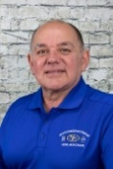 | Michael Gaffney  Director ASI  Associate Professor / Advisor  mgaffney@se.edu  580-745-3245  Durant Eaker Field Ops 102 | - MBA, University of Bridgeport, 1987  B.S., St. Louis University, 1981  - Flight Certificates and Ratings: ATP, CFI, CFII, MEI, A&P Mechanic, Ground Instructor.  - Master Flight and Ground Instructor Emeritus  - 2007 FAA National Flight Instructor of the Year
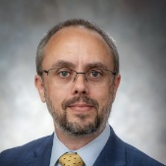 | Mike Amason  Asst. Professor / Chair of Professional Pilot / Advisor  mamason@se.edu  580-745-3240  Durant Eaker Field Ops 103 | - M.B.A, Salem International University  - B.S. Aviation – Professional Pilot – Southeastern Oklahoma State University  - Certificates: ATP, CFI, CFII, MEI, Ground Instructor  - Type Ratings: CE-500, CE-560XL, CE-650, DA50, DA7X, IAJET, G280, GVII
 | Janeva Maxson  Asst. Professor / Chair of Aviation Management / Advisor  jmaxson@se.edu  580-745-3241  Durant Eaker Field Ops 104 | - MS, Southeastern Oklahoma State University  - MA, Naval War College  - BS Marketing, Southeastern Oklahoma State University  - 29 Year Air Force Civil Servant – Senior Leader in Logistics, Finance, and Operational Support
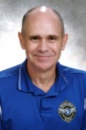 | Kyle Thomas  Assoc. Professor / Chief Flight Instructor / Operations Manager  kthomas@se.edu  580-745-3246  Durant Eaker Field Ops 210 | - B.S. Aviation – Professional Pilot - Southeastern Oklahoma State University  - M.A.S - Southeastern Oklahoma State University  - Flight Certificates and Ratings: ATP, CFI, CFII, MEI  - FAA Designated Pilot Examiner  - Master Instructor 2006 through 2024
 | Daniel Caterinicchio  Lead Flight Instructor /  Check Instructor/ Student Advisor  dcaterinicchio@se.edu  580-745-3256  Durant Eaker Field Ops 209 | - B.S. Aviation – Professional Pilot – Southeastern Oklahoma State University  - Flight Certificates and Ratings: Commercial, Instrument, CFI, CFII, Multi-Engine
 | Cassie Hill  Flight Administrator / FAA Testing  cwoodward@se.edu  580-745-3252  Durant Eaker Field Ops 111 | - MBA, Southeastern Ok State University  - B.S. in Accounting from Southeastern  - Certificate of Bookkeeping from Kiamichi Center  - FAA Knowledge Testing Center Administrator
 | Michael Mitchell  Aviation Adjunct Professor  mmitchell@se.edu  580-745-3242  Durant Eaker Field Ops 105 | - Ed.D Student, Aviation & Space Education, OSU  - MS, Aviation & Space Science, Oklahoma State University  - BS, Aerospace Admin & Operations, Oklahoma State University  - Certified Member (C.M.), American Association of Airport Executives (AAAE)
 | Tim Hunt  Faculty – Transport Aircraft  thunt@se.edu  580-745-3205  Durant Eaker Field Ops 101 | - B.S. Aviation Management - Southeastern Oklahoma State Univ.  - Major Airline Pilot - Retired, Former B737 Chief Instructor  - Certificates: ATP, FE-Turbojet, AGI, A&P  - Type Ratings / Flown: B-717, B-727, B-737, DC-9
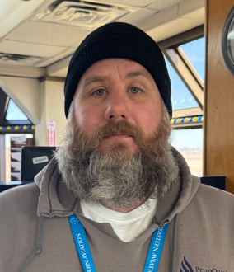 | Randall Dewitt  Supervisor Dispatch & Line Service  rdewitt@se.edu  580-745-3243  Durant Eaker Field Ops 214 | - Retired US Army Chief Warrant Officer 4  - US Army AH64 helicopter pilot  - US Army Maintenance test pilot  - US Army Maintenance standardization pilot

Aviation Sciences Institute Durant Operations Team - Spring 2025
Durant Aircraft Maintenance Team
 | Ken Williams  Aviation Maintenance Manager  kwilliams@se.edu  580-745-3329  Durant Eaker Field Operations MX | - FAA Airframe and Powerplant Mechanic  - FAA Inspection Authorization
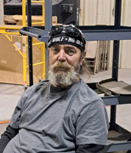 | David Palmer  Lead Aircraft Technician  dpalmer@se.edu  580-745-3278  Durant Eaker Field Operations MX | - FAA Airframe and Powerplant Mechanic  - FAA Inspection Authorization
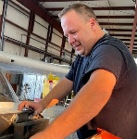 | Jordan Blackburn  Quality Inspector  jblackburn@se.edu  580-745-3284  Durant Eaker Field Operations MX | - FAA Airframe and Powerplant Mechanic  - FAA Inspection Authorization
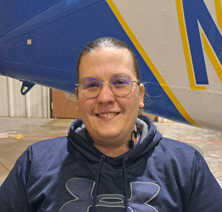 | Leslie Jeter  A&P Aircraft Technician  ljeter@se.edu  580-745-3281  Durant Eaker Field Operations MX | - Associates in Applied Science-Aviation Maintenance Technology, Eastern New Mexico University-Roswell  - FAA Airframe and Powerplant Mechanic  - FAA Inspection Authorization
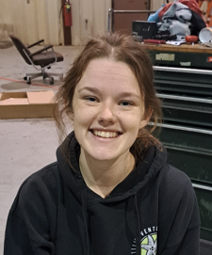 | Layla Shull  A&P Technician – in training  lshull@se.edu  580-745-3280  Durant Eaker Field Operations MX | - Kiamichi Tech Maintenance Certification
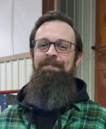 | Jeff Tate  Inventory Control  jtate@se.edu  580-745-3234  Durant Eaker Field Operations MX | - Talon RMS Implementation  - Inventory Control  - Aircraft GPS database
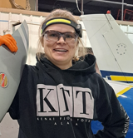 | Sarah Horan  A&P Technician  shoran@se.edu  580-745-3234  Durant Eaker Field Operations MX | - B.S. Mission Aviation – LeTourneau University  - A&P Mechanic  - FAA Commercial Pilot  - FAA Flight Instructor
Durant Flight Training Leadership Team
 | Ben Williams  Senior Flight Instructor  sgutierrez@se.edu  580-745-3262  Durant Eaker Field Operations 207 | - B.S. Aviation – Professional Pilot – Southeastern Oklahoma State University  - Flight Certificates and Ratings: Commercial, Instrument, CFI, CFII
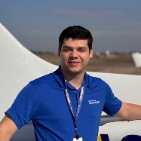 | Peyton Kirby  Senior Flight Instructor  pkirby@se.edu  580-745-3254  Durant Eaker Field Operations 207 | - B.S. Aviation – Professional Pilot – Southeastern Oklahoma State University  - Flight Certificates and Ratings: Commercial, Instrument, CFI, CFII, Multi-engine Instructor
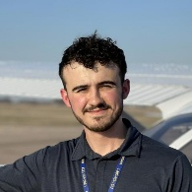 | Nathan Lopez  Senior Flight Instructor  nlopez@se.edu  580-745-3259  Durant Eaker Field Operations 205 | - B.S. Aviation – Professional Pilot – Southeastern Oklahoma State University  - Flight Certificates and Ratings: Commercial, Instrument, CFI, CFII, Multi-engine Instructor
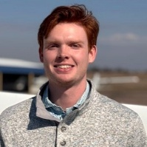 | Jeff Walraven  Senior Flight Instructor  jwalraven@se.edu  580-745-3259  Durant Eaker Field Operations 205 | - B.S. Aviation – Professional Pilot – Southeastern Oklahoma State University  - Flight Certificates and Ratings: Commercial, Instrument, CFI, CFII, Multi-engine Instructor
 | Seth Hill  Staff Flight Instructor/ Safety Officer  shill@se.edu  580-745-3250  Durant Eaker Field Operations 120 | - B.S. Aviation – Professional Pilot – Southeastern Oklahoma State University  - Flight Certificates and Ratings: Commercial, Instrument, CFI, CFII

Aviation Sciences Institute Oklahoma City Faculty / Staff - Fall 2025
 | Janeva Maxson  Asst. Professor / Chair of Aviation Management / Advisor  jmaxson@se.edu  580-745-3241  Durant Eaker Field Ops 104 | - MS, Southeastern Oklahoma State University  - MA, Naval War College  - BS Marketing, Southeastern Oklahoma State University  - 29 Year Air Force Civil Servant – Senior Leader in Logistics, Finance, and Operational Support
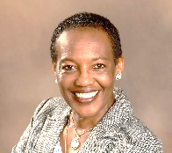 | Dr. Angela Anderson  Assistant Professor  aanderson@se.edu  405-736-0222  Community Learning Center, Suite 200, Rose State College Campus | - Ph. D., Capella University, Org/Mgt-Leadership  - M.S, University of Oklahoma, Human Relations Mgmt.  - Acquisition Product Support Manager-Level IV for DoD Programs  - 30+ years leading various logistics and program management programs within the DoD
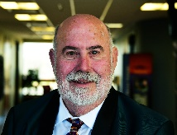 | Dr. Michael Friday  Assistant Professor  mfriday@se.edu  405-642-9535  Community Learning Center, Suite 200, Rose State College Campus | - Ed.D., Aviation, Oklahoma State University  - MBA, University of Central Oklahoma  - BSEE, Computers, University of Miami  - 34 years USAF - Engineering & Logistics Oklahoma City Air Logistics Center  - Private Pilot & Aircraft Owner
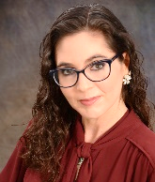 | Lara Bernhardt  Director, OKC Academic Programs/Adjunct Instructor lbernhardt@se.edu  405-733-2210  Tinker AFB, Building 201SE, Suite 105 | - MEd, English Education, Southeastern Oklahoma State University  - BA from the University of Tulsa  - 9 years of experience in higher education
 | Audrey Anderson  Office Manager  ananderson@se.edu  405-733-2210  Tinker AFB, Building 201SE, Suite 105 | - Trainee

