How to Use the Textbook Reserve Program (TRP)

Step 1: Find out if the library holds the textbook title
The first step in using the TRP is to determine if the library holds the same title and edition as the course material required. There are limitations for the type of textbook content that can be added to the reserve collection, so it is not guaranteed the library will have the material required for your course. The campus bookstore would be your ideal place to obtain the materials for this reason.
There are two ways to search for your textbook title to see if the library owns a copy.

Method #1: Use the Library Discovery Search Tool
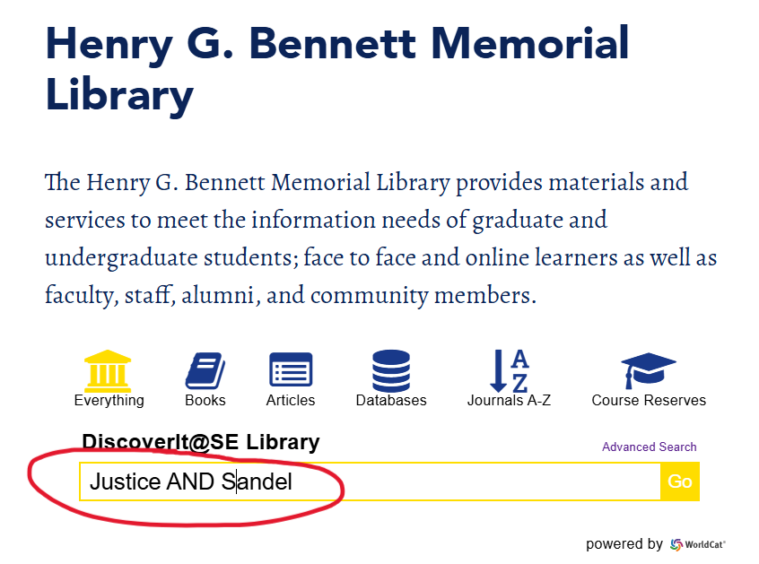
Enter a simple keyword/ key phrase search string that contains a brief title and an author’s surname along with the Boolean operator, AND, in the search toolbox then hit “go.”
You will be taken to a results page with many records that fit your keywords. If you find the record with your title’s information you will see if SE Library owns it and if it’s location is within the TRP collection.
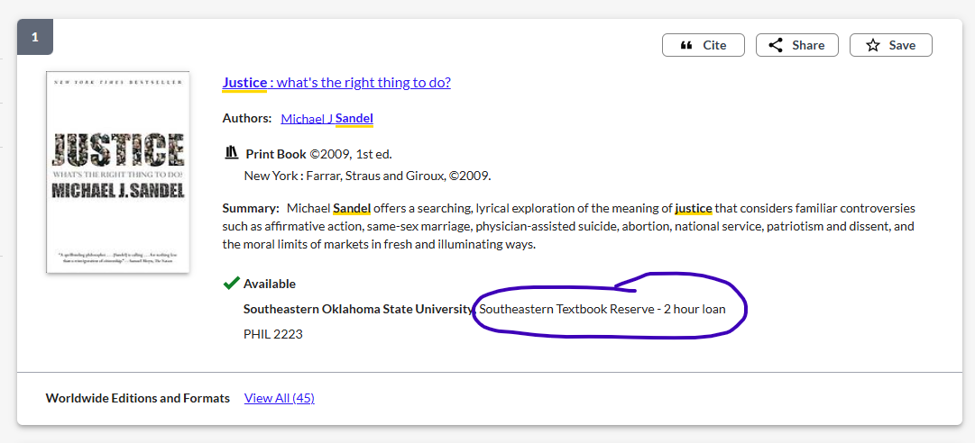
If you do not find the book title with this type of search, you may want to check your terms or try the second method.

Method #2: Search the Course Reserves Collection
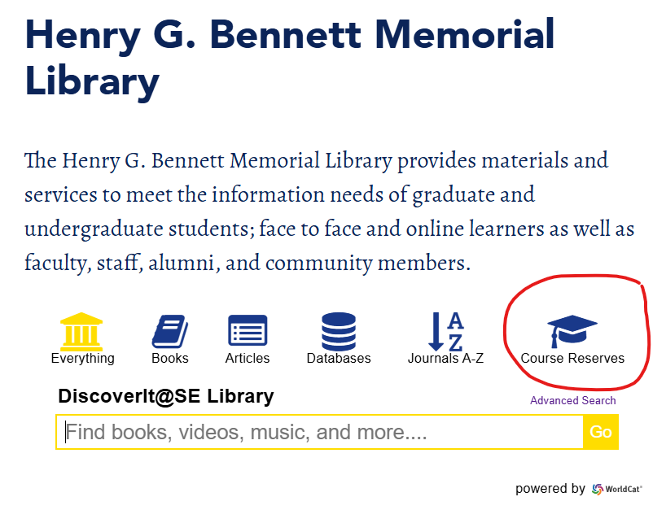
The second way to search is to go to the Course Reserves icon above the search tool on the far right of the search box.
This will open a new tab and present you with another search box, but this one is limited to search only through the reserves collection and restricts search terms to only the course or instructor name.
It is best to search using the course information as instructors can vary if multiple sections are offered or change before the library gets the information to keep it up to date, but brief course numbers rarely change.
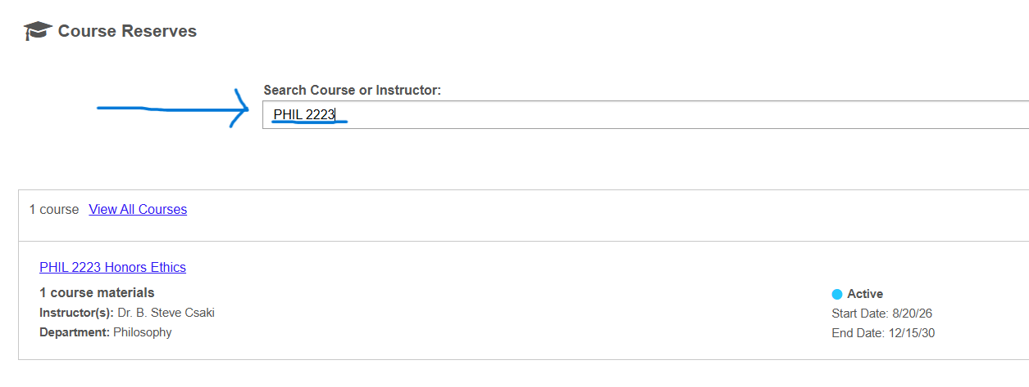
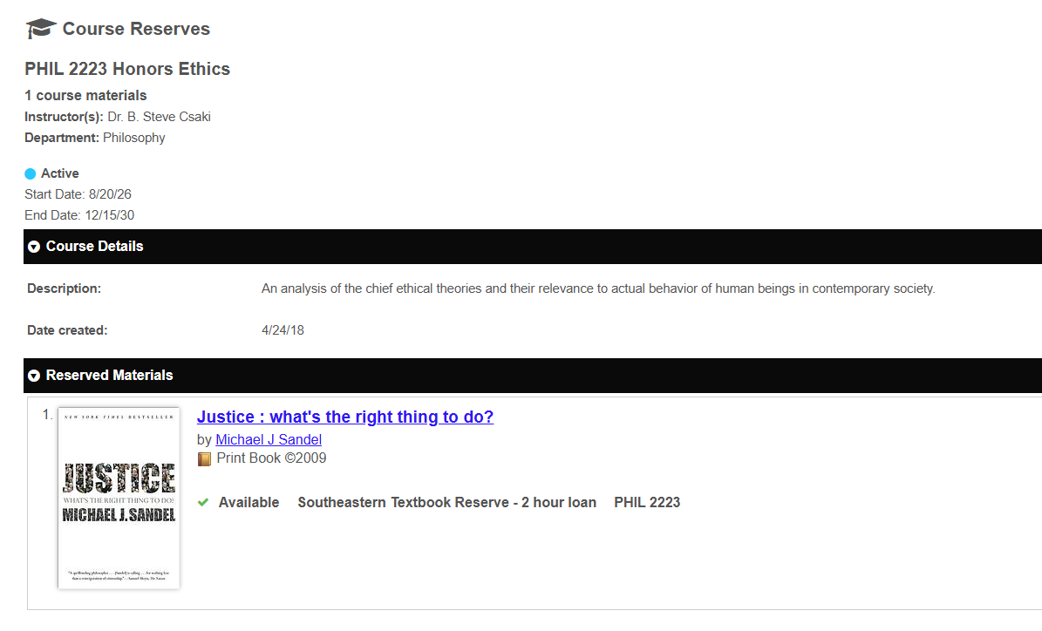
Once you find the record for the course, you will click the hyperlink to look and see what title(s) and editions the library has available. Edition cannot be stressed enough to check.
If we have an older edition of the same title, you will want to check with your instructor to verify it can be used for the course.
Once you know the library has the title you can move on to making a request.

How to Make a Request for a Chapter from the TRP

Access Options: 2hr In-Library Use Only or Scanned Chapter Request
You can check out a textbook for two-hour in-library use at the circulation desk using your SE student ID. If you cannot come to campus, the library can email you a scan of one chapter per title each day. All requests for scanned chapters must be submitted using the Textbook Chapter Request Form. Below are the steps to place your request.

Step 1: Undergraduate Student Services Page
Navigate to the Chapter Request form button on the Undergraduate Student Services page.
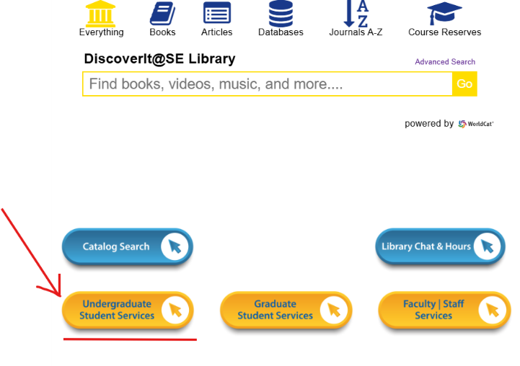
From the library’s homepage, you will select the yellow button labeled “Undergraduate Student Services.” You will find it on the left side of the page, directly under the blue “Catalog Search” button.
You may need to scroll down past the Discovery Search tool to see the buttons for selection.

Step 2: Expand Accordion Section
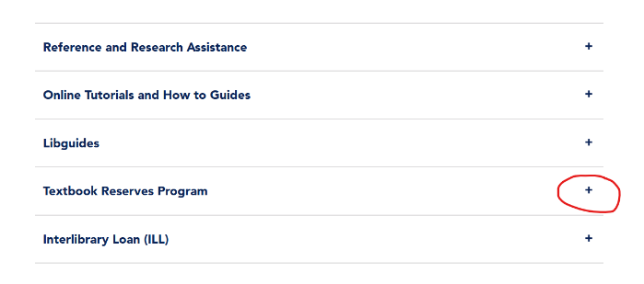
A new tab will open to a page with a short list of library services that are helpful to this learning community. There are brief descriptions and links relevant to the services in each section. You will select the plus sign (+) next to the Textbook Reserves Program to expand the section information.
You will see two links in the expanded section. One will take you to the full information page about the program; the other is a quick link to the Chapter Request form.

Step 3: Select Chapter Request Form.
Click on the blue button labeled “Chapter Request form”. The form will open in a new tab. 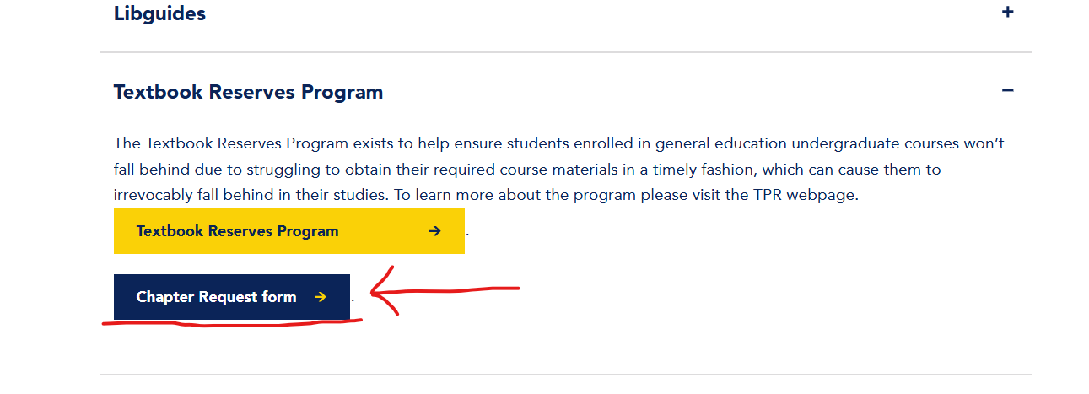

Step 4: Fill Out Form
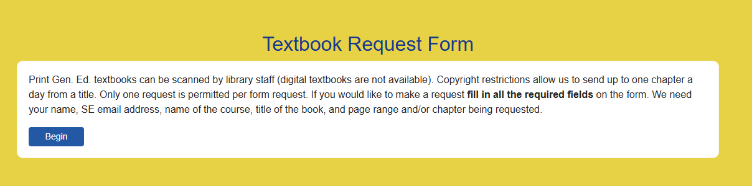
Select the “begin” button and fill out all required fields on the form.
* Pay close attention to edition if your required textbook title has one when filling out the form.

Step 5: Review your request information
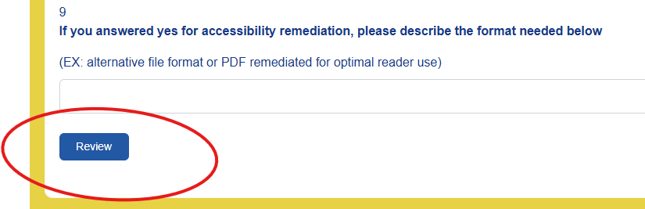

Step 6: Submit Request
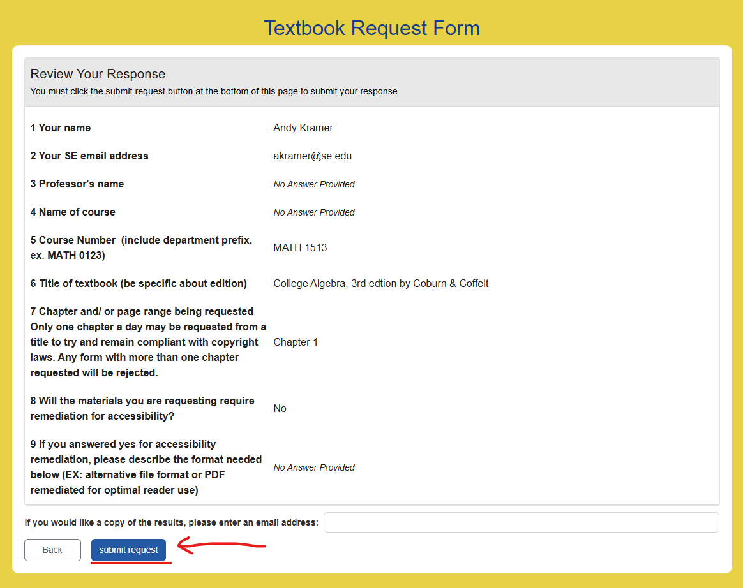
A PDF file containing the scanned chapter information will be sent via your SE student email. The staff attempt to fulfill all requests during the hours of operation on the same day they arrive. Please note that no requests will be fulfilled in the last hour of operation for the day so staff may begin their closing duties.

