Southeastern Oklahoma State University
Student Government Association
First Session of the One Hundredth Legislature
“Students Serving Students”
June 8, 2020
7:00 P.M.
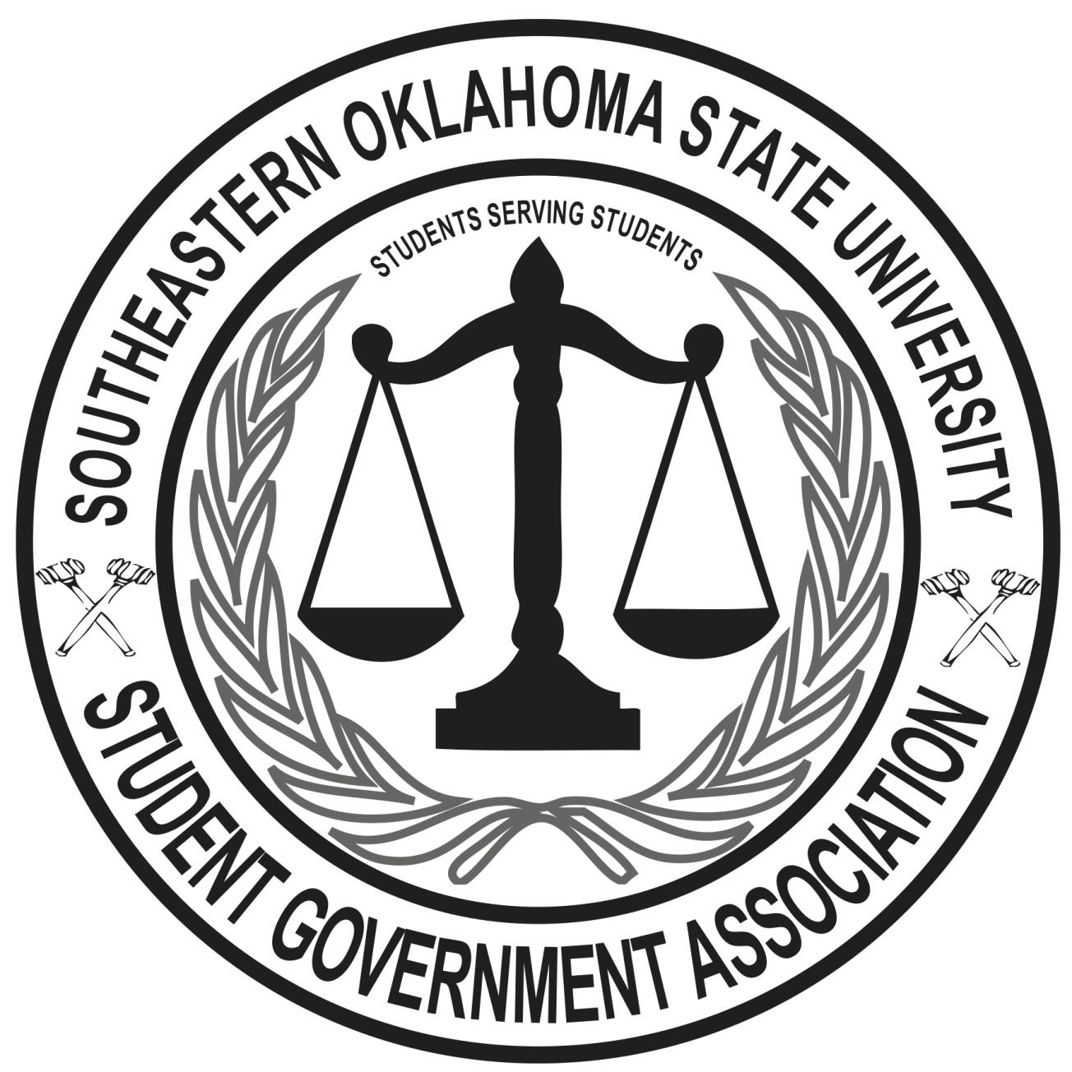
Agenda

Call to Order
Roll Call
Announcement of Quorum
Pledge of Allegiance
Approval of Minutes
Officer Reports
President Antuono:
Vice President Quarles:
Secretary Caldwell:
Executive:
Internal Reports
Approval of Release of SGA Statement
Approval of Event Sponsorship
Old Business
New Business
Resolution #001
Public Comments
Campus Concerns and Compliments
Announcements
Any Matter Not Known About Before the Agenda Was Posted
Adjournment

